**PROGRAMME:** BCS/BNCS/BAI/DIT/BBA/BAF

**YEAR/SEM:** YEAR 1 SEM I

**PROBLEM NAME:** COMPUTER SETTINGS & OFFICE WORK

**STUDENT DETAILS:**

|  |  |
| --- | --- |
| **NAME OF STUDENT** | **Mukisa Trevor** |
| **ROLL NUMBER** | **011250372** |

**Table of Contents:**

**List of Figures:**

**Question 1**

**PRACTICAL SOLUTION OVERVIEW:**

|  |  |
| --- | --- |
| **STEP #** | **STEP DETAILS** |
|  |  |
|  |  |
|  |  |

**SCREENSHOTS & DETAILED EXPLANATIONS OF THE STEPS**

**STEP #1:** Create New Presentation

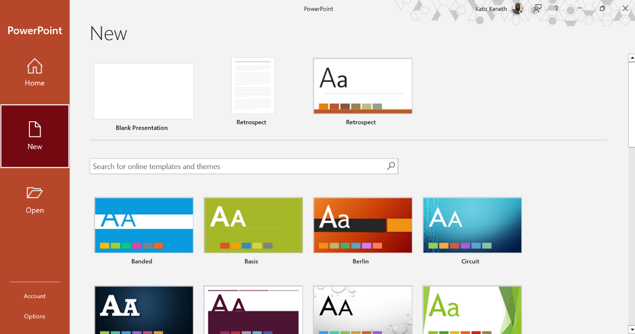

During this step, i selected a presentation template to use for my document.

**STEP #2:** Adding slides to the presentation

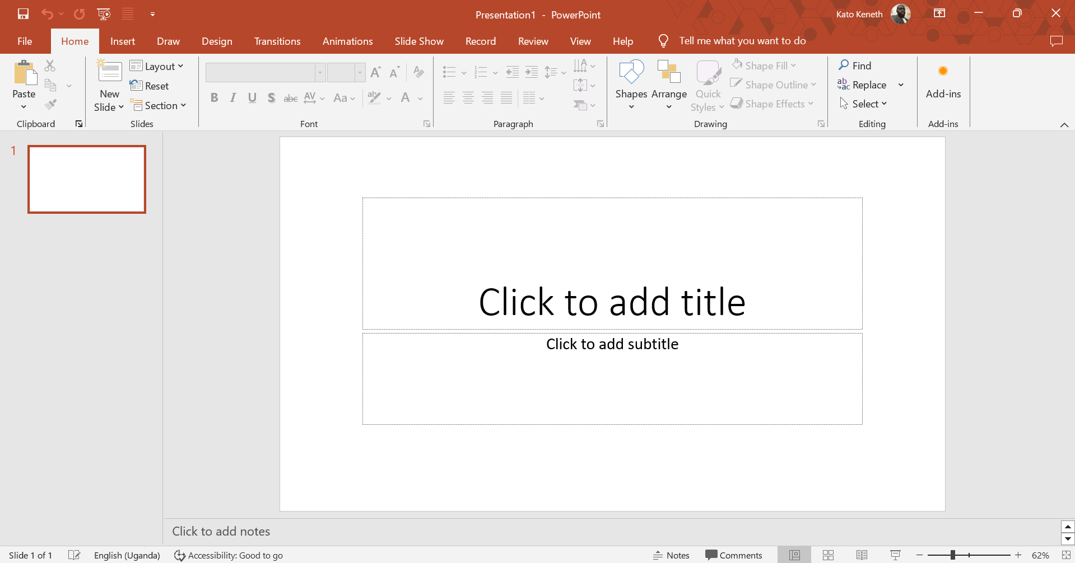

During this step, i added slides to my presentation.

**STEP #3:** Configuring Master Slide Styles

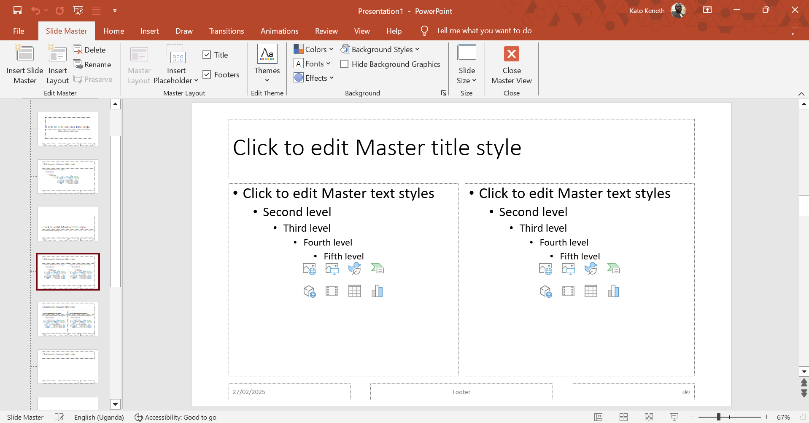

During this step, i configured the master style template for my presentation document.

**Task Summary (**What i have learnt from the Task**)**

|  |  |
| --- | --- |
| **Skill Set** | **Description** |
|  |  |